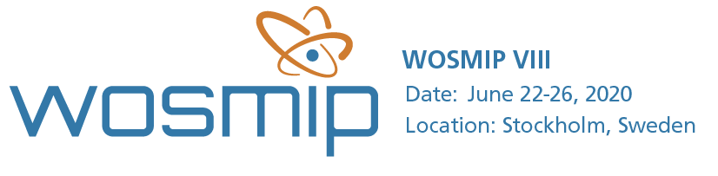

Dear WOSMIP Colleagues,

Due to unavoidable issues associated with the COVID-19 crisis, we will have to postpone the 2020 Stockholm WOSMIP workshop that was scheduled for the week of June 22nd. It is our intent to reschedule this important meeting in late Spring or early Summer next year (2021), at the same or a similar venue in Stockholm - details will follow and we will keep the WOSMIP website updated as plans progress.

If you have already submitted an abstract, please consider keeping it on hold for the workshop next year! We will be sending out another updated solicitation once some of the details have been worked out. If you have made hotel reservations, please don’t forget to cancel them. The contact us page for Hilton Hotels will aid in this process. We are happy to assist you if necessary.

We are considering an activity to keep the momentum in this area, and we may be reaching out to you individually or as a group as the plans come together. Please feel free to drop us any suggestions you might have.

Although we are disappointed to postpone, we hope you are in good health and wish the best to you and your families.

Best regards,

The WOSMIP Organizing Committee

